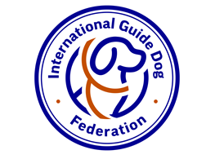
International Guide Dog Federation (IGDF)
Company no: 2376162. Registered Charity no: 1062441

ENQUIRING ORGANISATION APPLICATION
THIS FORM IS TO BE COMPLETED IN ENGLISH
I hereby apply to become an Enquiring Organisation of The International Guide Dog Federation (“IGDF”) on behalf of:
______________________________________________________________________________Name of Organisation/Foundation

1. | Name of Primary contact:
 | Position:
 | Address:
 | Post Code:
 | Country:
Telephone Number:
(include Country Code)
Facsimile Number:
(Include Country Code)
 | E-mail address:
 | Website:
 | Second contact name:
 | Second contact telephone number:
 | Second contact email address:
2. | Date of legal entity/ incorporation:

3. | What are your organisation’s development plans for the future? Please detail below.

________________________________________________________________________

________________________________________________________________________

________________________________________________________________________

4. | What Guide Dog Services already exist within your country or state? If others please present a brief case for the need of an additional Guide Dog Organisation.

________________________________________________________________________

________________________________________________________________________

________________________________________________________________________

With effect from 1st January 2023:
New EOs will not pay an annual subscription for the year in which their EO status is approved, and will then pay an annual subscription of £100 per year.

Signed:
Name in Full:
Status (Title):
For and on behalf of:
(Name of Organisation/Foundation)
Date:

